
Http Basics and proxies
By Abhinaya Barailee

September 15, 2024
MSU Denver

HTTP Basics
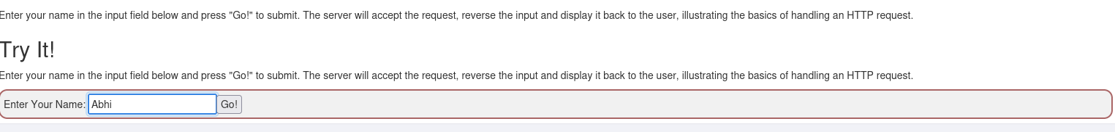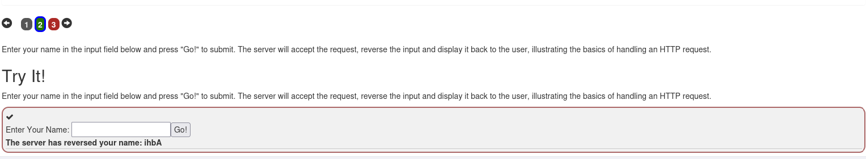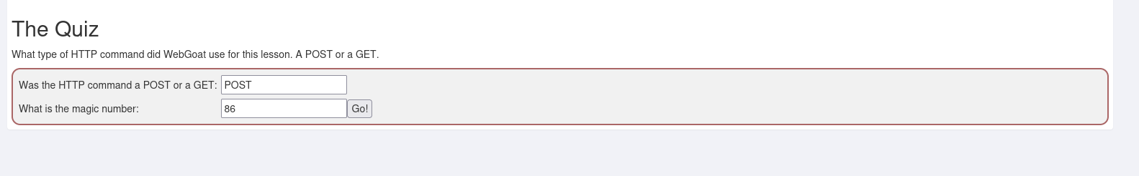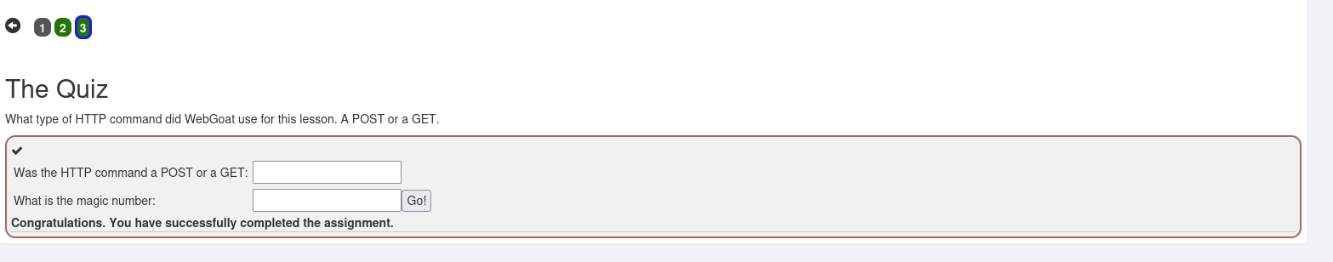

HTTP Proxies

